For the villain I have called them paul-itician and based them of off our teacher paul, he takes inspiration from senator armstrong he is going to be quite ripped and loud shouting most of the time, Ive decided to make the weapons he drops for the player a megaphone, i have made posing concept art for him on what pose i want him to be in for the concept art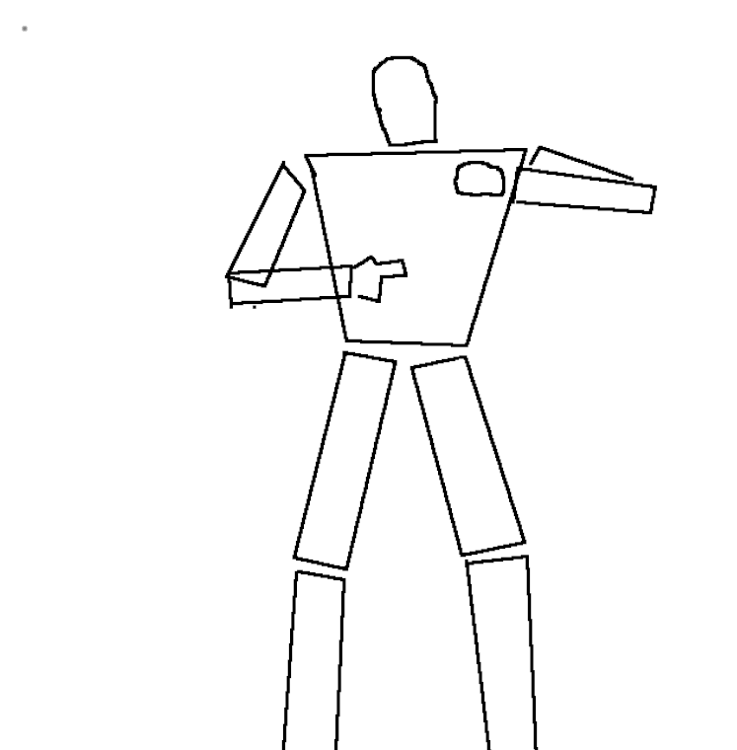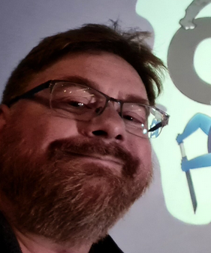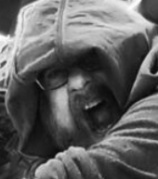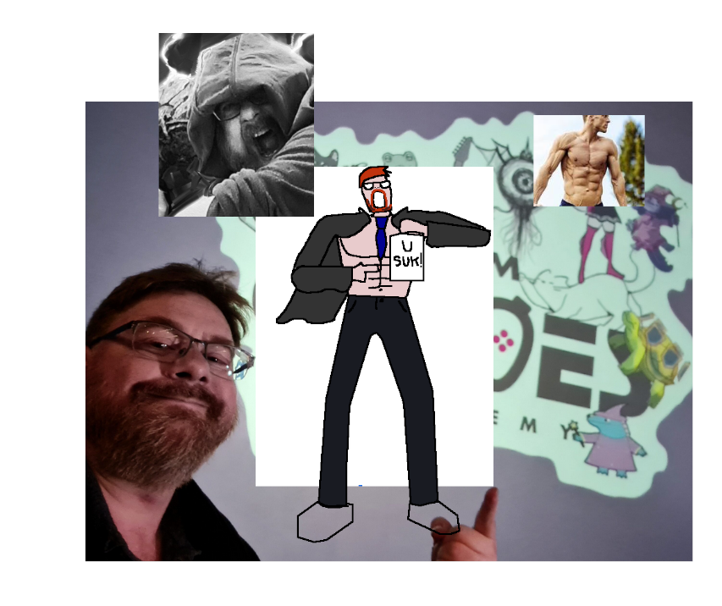I traced clothes around the pose and colored them in flatly i decided to give paul a cape/half suit as well as a tie to show how he is smart while leaving his sixpack visible in a similar vein to senator armstrong from metal gear rising revengence I replaced his tie with a craavat to be more period accurate im also gonna give him a medieval megaphone as a weapon the player obtains it can be used to shout loudly and stun people,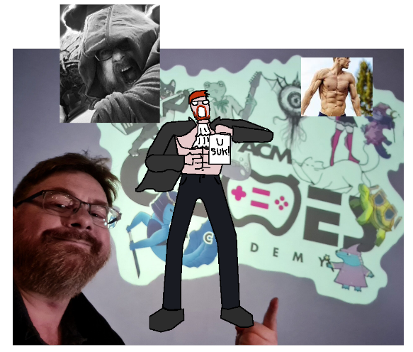for the scene i first rendered it in 3d using a drawing of a council hall as reference I added a sun light source outside of the room to give it light 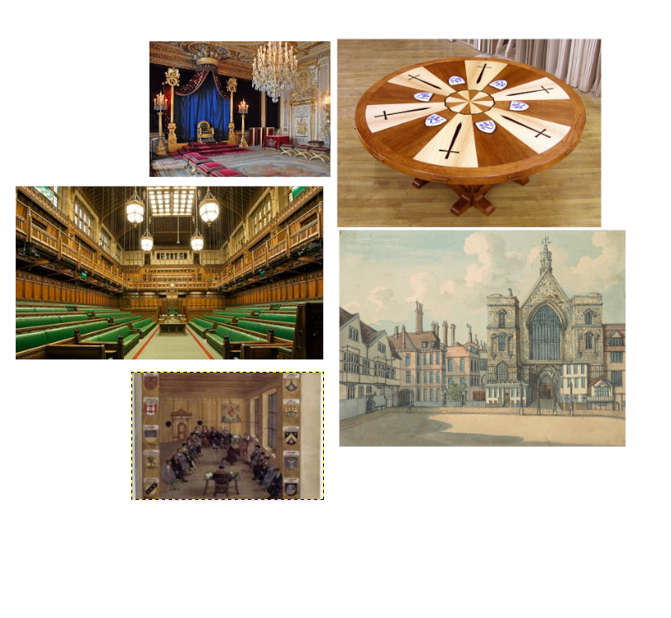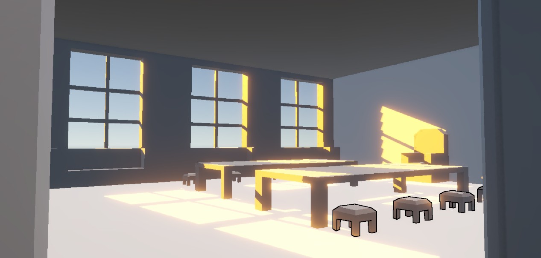I proceeded to trace around the parts of the room before filling them in with colors picked from the reference images, i then moved the original render to the top and set it to render in overlay mode shading in the image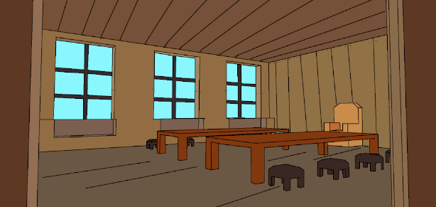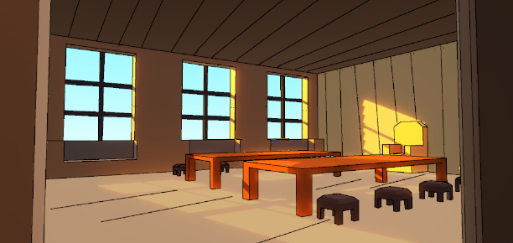 I then pasted the boss into the image positioned him ontop of the table and above the shading layer before using the fill bucket and pencil to edit his shadows and then adding another shading layer ontop of him to shade in his body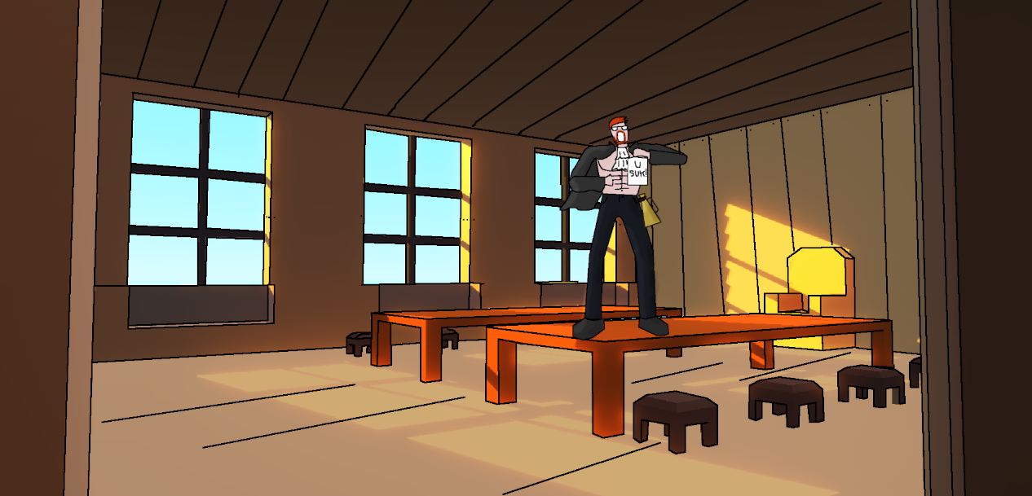
Now I needed to work on the main character, I based my main character of of hatsune miku and made her a mage in a cloak I drew this over an image of hatsune miku to make her proportions look right and to do her perspective drawing attempted to use a malformed cube to help me properly position her body parts as she was wearing a cloak it was alot simpler to position and place her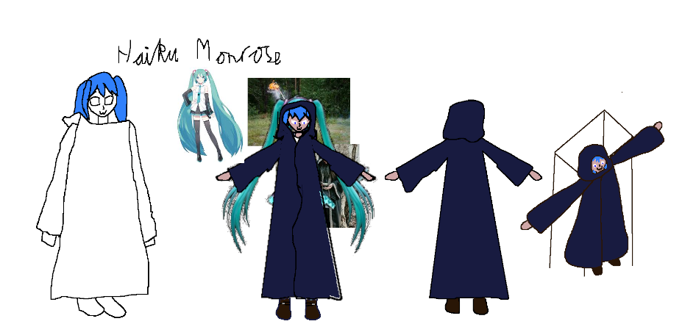 to make the upgraded version of her I gave her a cravaat and the bosses megaphone, I then shaded the haikus in by adding a grey overlay layer and manually painting colors of either lighter or darker tones on haiku I then used the smudge tool to smooth the edges of the shading and make it look more natural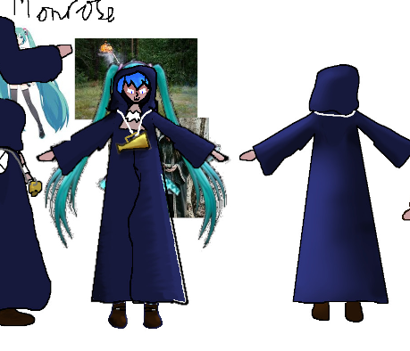
To do the banner i screenshooted the bossarena before selecting the area i wanted visible by drawing an outline of the banner before going back to the screenshot and using the lasso select to select everything inside before cutting and pasting to get the banner, I then drew the boss inside the banner grabbing on to the sides and pointing at us, before shading in the same way i did before, i later found that the shading looked cooler when multiplied when getting a visible layer to show to my peers and as such duplicated the shading layer. Some edits to the banner were requested and i moved around props and such to fulfil said requests as well as rotating the trumpets so they would take up less space I then cut the shading i had done over them before making a new shading layer and manually shading them again so the shading would be in the correct position
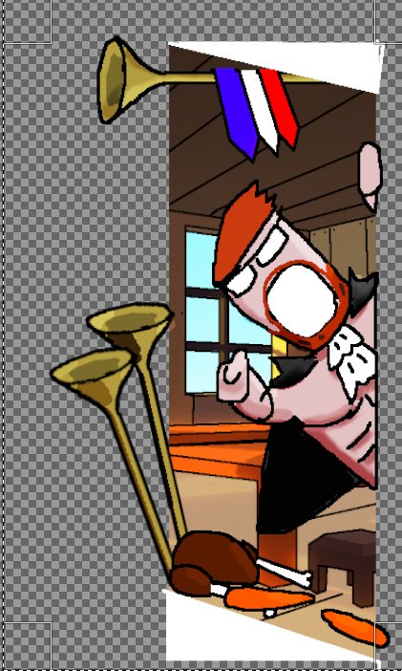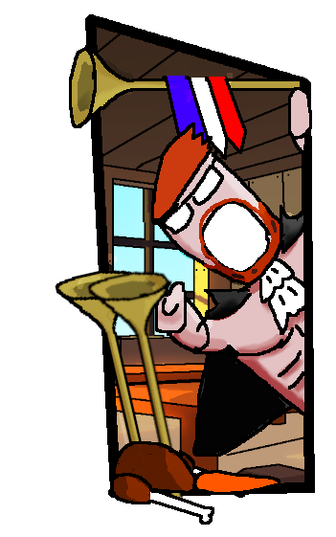
Before and after

